PROJECT TITILE
DoS Attack Detection and Traffic Visualization System

M VARSHITH REDDY SHASHIDHAR
CYBER SECURITY CYBER SECURITY MENTOR
TA1CS1025123 TEKS ACADEMY
TEKS ACADEMY 9603343287
9390542631

1.Abstract:
Denial-of-Service (DoS) attacks are among the most common and disruptive cyber threats, where an attacker overwhelms a system, server, or network with excessive traffic, making it unavailable to legitimate users. With the rapid growth of network-based services, the need for effective detection and monitoring of such attacks has become critical.
This project presents a lightweight and efficient DoS Attack Detection System developed using Python. The system captures live network traffic using packet sniffing techniques and analyzes the data to detect abnormal patterns such as SYN Flood and ICMP Flood attacks. By applying threshold-based detection logic, the system identifies suspicious traffic behavior in real time.
The captured data is structured and stored using data analysis tools, enabling further processing and visualization. Graphical representations of network activity are generated to highlight traffic spikes, making it easier to interpret attack patterns. Additionally, a web-based dashboard is implemented to display real-time insights, including traffic statistics, attack alerts, and top sources of suspicious activity.
The project demonstrates how network security concepts can be implemented using simple yet powerful tools. It provides a foundation for building more advanced intrusion detection systems and highlights the importance of monitoring and analyzing network traffic to ensure system availability and security.

2. Problem Statement
With the increasing dependence on internet-based services, networks are becoming more vulnerable to cyber-attacks. One of the major threats is the Denial-of-Service (DoS) attack, which aims to disrupt the normal functioning of a system by flooding it with excessive requests.
Traditional systems often lack real-time monitoring and visualization capabilities, making it difficult to identify such attacks at an early stage. Without proper detection mechanisms, these attacks can lead to service downtime, data loss, and financial damage.
The challenge is to design a system that can:
- Monitor network traffic in real time
- Detect abnormal traffic patterns
- Identify potential DoS attacks
- Provide meaningful insights through visualization
This project addresses these challenges by developing a system that detects SYN Flood and ICMP Flood attacks using packet-level analysis and presents the results in an understandable format.

3. Project Objectives
The main objectives of this project are:
- To design and develop a system that captures live network traffic
- To analyze packet-level data for detecting abnormal patterns
- To identify SYN Flood and ICMP Flood attacks using threshold-based techniques
- To store captured data in a structured format for analysis
- To visualize traffic behavior using graphical representations
- To develop a web-based dashboard for monitoring network activity
- To provide insights such as top attacker IP and traffic statistics
- To create a user-friendly and efficient detection system
The project aims to provide both detection and analysis capabilities, making it a comprehensive solution for understanding DoS attack behavior.
4. Project Scope
The scope of this project is focused on detecting and analyzing DoS attacks within a controlled environment. The system is designed to monitor network traffic on a local machine or network and identify abnormal patterns based on predefined thresholds.
In-Scope Features
- Real-time packet capture
- Detection of SYN Flood attacks
- Detection of ICMP Flood attacks
- Data logging and storage
- Graph-based visualization of traffic
- Web dashboard for monitoring
- Identification of top traffic sources
Out-of-Scope Features
- Distributed Denial-of-Service (DDoS) detection
- Machine learning-based detection
- Automated firewall blocking
- Large-scale enterprise deployment
Limitations
- Threshold-based detection may not detect all attack types
- Requires administrative privileges for packet capture
- Limited to basic traffic analysis
Despite these limitations, the project provides a strong foundation for understanding network security concepts and can be extended in future.

5. Tools and Technologies Used
The project is implemented using the following tools and technologies:
Programming Language
- Python
Used for implementing packet capture, detection logic, and data processing.
Libraries
- Scapy
Used for capturing and analyzing network packets in real time.
- Pandas
Used for storing and analyzing structured data.
- Matplotlib
Used for generating graphs and visualizing traffic patterns.
- Flask
Used to create a web-based dashboard for displaying results.

Development Environment
- Kali Linux / Linux-based system
- Terminal for executing scripts

Other Tools
- Web browser for dashboard visualization
- Text editor (Nano / VS Code)

These technologies are lightweight, open-source, and suitable for building efficient network monitoring systems.

6. Deliverables
The project produces the following deliverables:
1. Source Code
- Packet capture script
- Data processing script
- Visualization script
- Web dashboard application
2. Data Files
- CSV file containing captured traffic data
3. Graphical Output
- Traffic graph showing SYN and ICMP activity
4. Dashboard
- Web-based interface displaying:
  - Alerts
  - Traffic statistics
  - Graphs
  - Logs
5. Documentation
- Project report
- Explanation of implementation
- Usage instructions

These deliverables collectively demonstrate the working and effectiveness of the system.

7. Project Implementation
This section explains the complete implementation of the DoS Detection System in a step-by-step manner. Each step includes commands, code execution, and expected outputs.

7.1 Environment Setup
Step 1: Update System Packages
Open terminal and run:
sudo apt update
Step 2: Install pip
sudo apt install python3-pip
Step 3: Create Virtual Environment
python3 -m venv dos-env
Step 4: Activate Virtual Environment
source dos-env/bin/activate
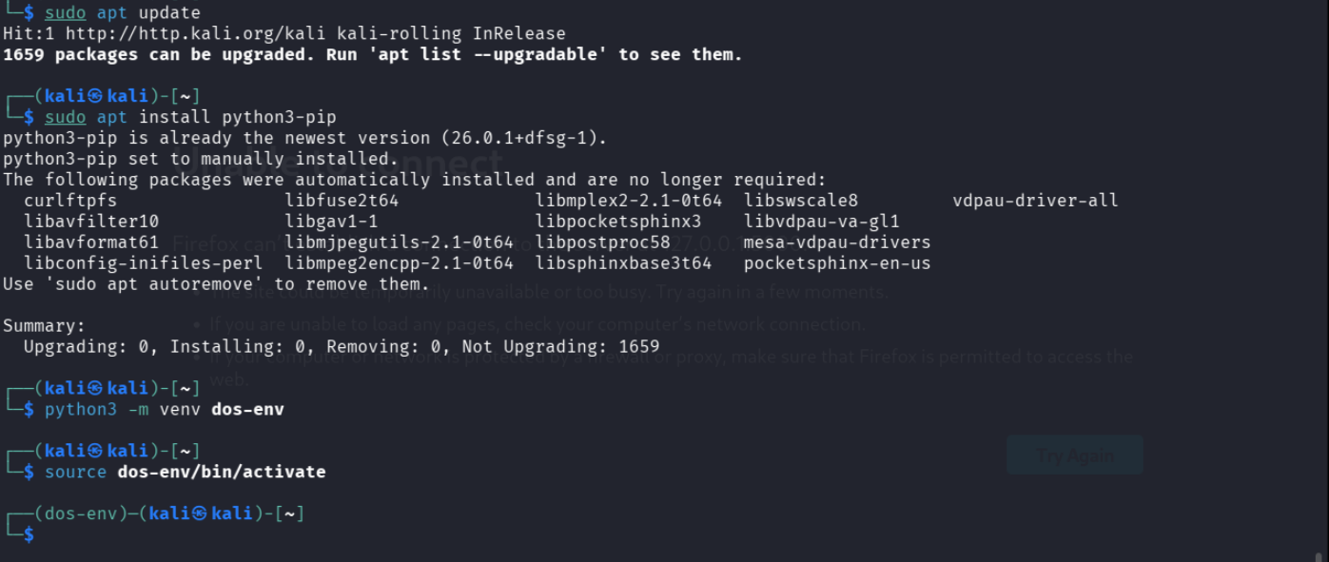

7.2 Install Required Libraries
pip install scapy flask pandas matplotlib

7.3 Packet Capture Implementation
Step 1: Create Script
nano packet_capture.py
Step 2: Add Code
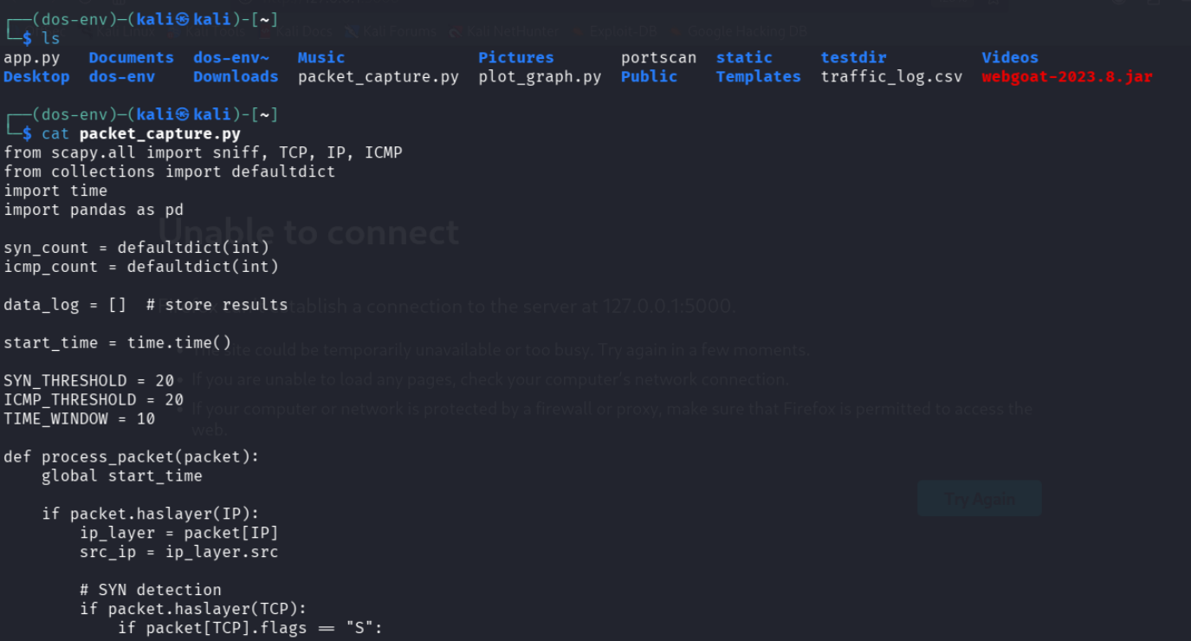

Step 3: Run Script
sudo python packet_capture.py
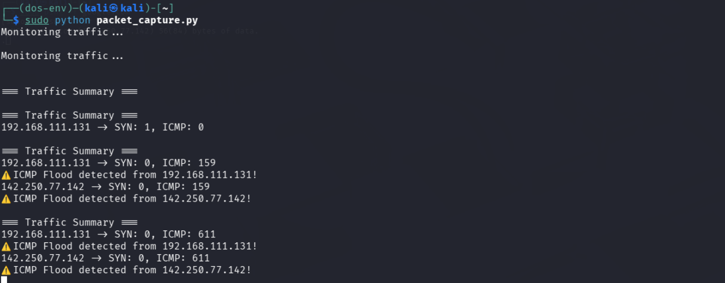

7.4 Traffic Generation for Testing
To test the system, generate network traffic.
Normal Traffic
ping google.com
ICMP Flood (Attack Simulation)
sudo ping -f 127.0.0.1

7.5 Detection of Attacks
During execution, the system analyzes packets and detects anomalies.
Expected Output
=== Traffic Summary ===
192.168.x.x -> SYN: 0, ICMP: 600
⚠️ ICMP Flood detected!

7.6 Data Logging
Step 1: Stop Script
Press: CTRL + C
Step 2: CSV File Generated
traffic_log.csv
Step 3: View Data
cat traffic_log.csv
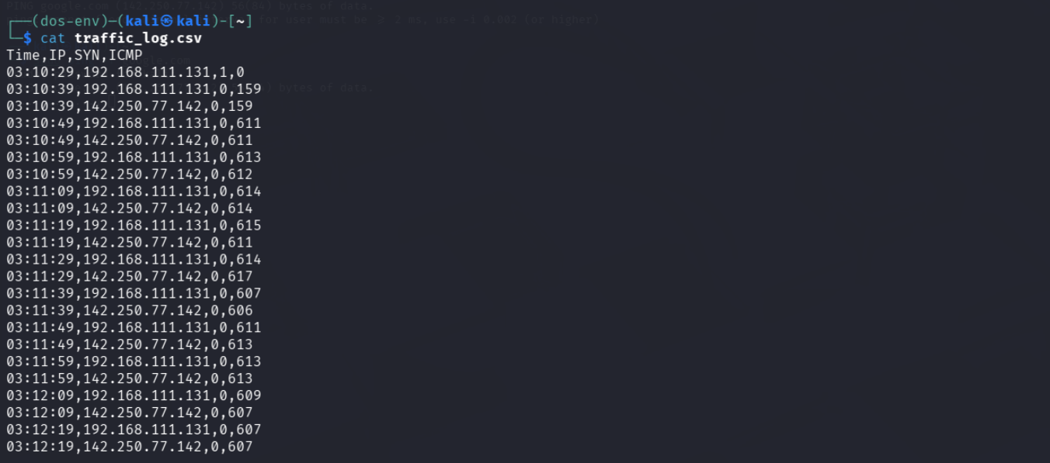
7.7 Data Visualization
Step 1: Create Graph Script
nano plot_graph.py
Step 2: Run Script
python plot_graph.py
Step 3: Graph File Generated
traffic_graph.png

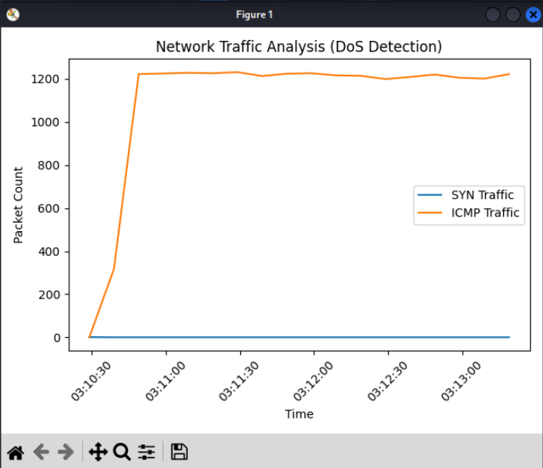

7.8 Web Dashboard Implementation
Step 1: Create Flask App
nano app.py
Step 2: Run Flask Server
python app.py
Step 3: Open in Browser
http://127.0.0.1:5000
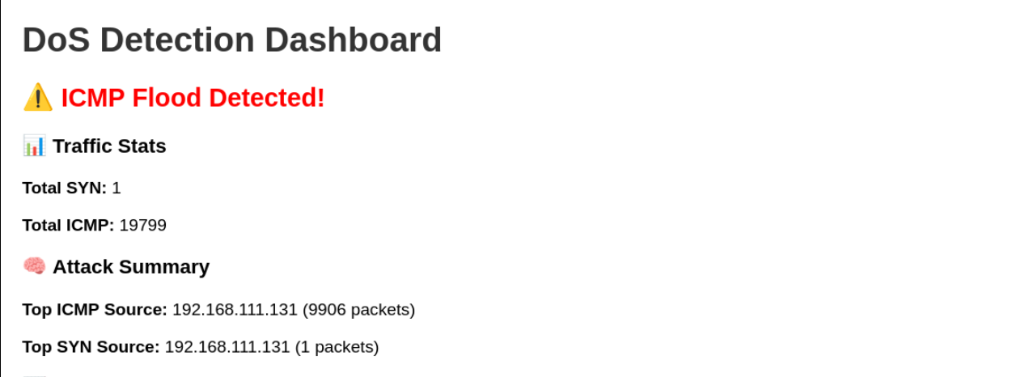
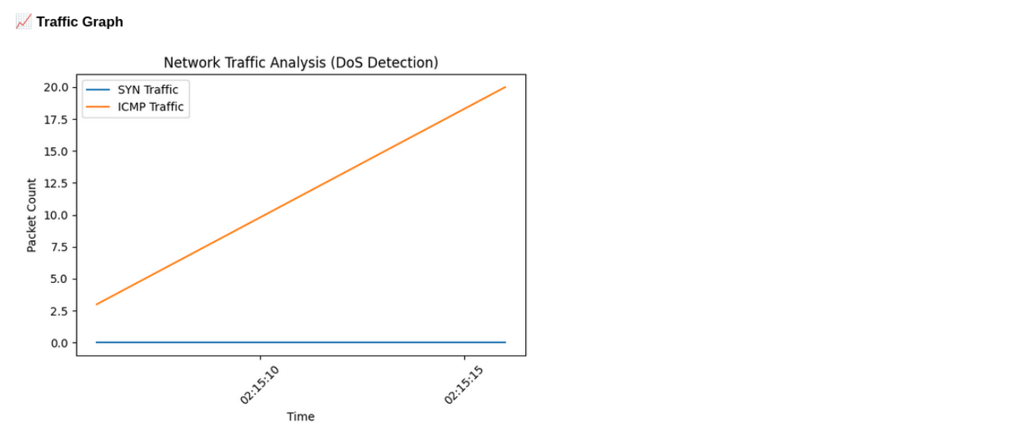
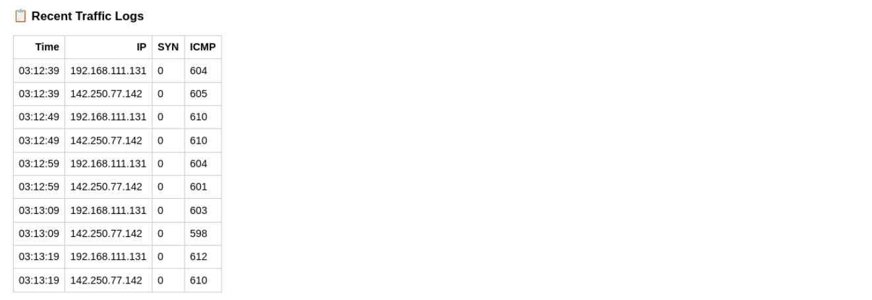

7.9 Real-Time Monitoring
The dashboard refreshes automatically every few seconds.

8. Conclusion

This project successfully demonstrates the design and implementation of a DoS Attack Detection System using Python. The system effectively captures and analyzes network traffic to detect abnormal patterns such as SYN Flood and ICMP Flood attacks.
By combining packet analysis, data processing, and visualization techniques, the project provides a comprehensive approach to understanding network behavior. The inclusion of a web-based dashboard enhances usability and makes the system more interactive and informative.
The project highlights the importance of monitoring network traffic and provides a foundation for building advanced security systems. It also demonstrates how simple tools can be used to implement practical solutions for real-world problems.
Overall, the system achieves its objectives and serves as a valuable learning experience in the field of network security.

